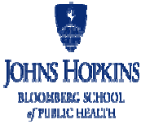

Institutional Review Board Office
Phone: 410-955-3193
Toll Free: 1-888-262-3242
Email: bsph.irboffice@jhu.edu
Website: www.bsph.edu/irb
Johns Hopkins Bloomberg School of Public Health Institutional Review Board

Certification of GCP Training
(must be typed)

Principal Investigator (PI):
IRB Number:
Study Title:
Study Team members:
Date:
Signature of PI:
I certify that the study team members listed above have completed all modules for the GOOD CLINICAL PRACTICE (GCP) FOR SOCIAL AND BEHAVIORAL RESEARCH FIELD GUIDE and have successfully completed an assessment for the guide.
Certification: To be completed by the Principal Investigator
Submit a copy of this document to the IRB and keep a copy in the study records.

JHSPH IRB Certification of GCP Training
V7 August 2023

