JHSPH IRB’s PHIRST SYSTEM
(Public Health Institutional Review System Tracking)

USER GUIDE
For Investigators, Students, Study Team Members

developed by

Johns Hopkins Bloomberg School of Public Health Institutional Review Board (IRB) Office
615 N. Wolfe Street Suite E1100
Baltimore, Maryland 21205
410-955-3193
JHSPH.irboffice@jhu.edu JHSPH.phirsthelp@jhu.edu

Table of Contents
Welcome to PHIRST! 3
Who should register in the PHIRST system? 4
Access to PHIRST and Account Registration 4
Your PHIRST Homepage – My Inbox 6
Creating a New Application 7
Adding Study Team members 8
Navigation 9
Uploading Documents 10
Submitting your application 12
The Application Workspace 13
Application Review Process 15
Responding to Concerns 15
Revising documents in response to IRB concerns 16
Your Approved Application! 17
After Initial Approval 17
Further Submissions 18
Amendments 18
Further Study Submissions: Continuing Reviews, Other Administrative Submissions, Final Study Report 22
Finding your Further Study Submissions 23
Addendum A 24

Welcome to PHIRST!
PHIRST is a web-based application system used by the Johns Hopkins Bloomberg School of Public Health Institutional Review Board (JHSPH IRB) as a portal for submission and review of human subjects research studies.

This user guide was developed specifically for investigators, students, and study team members and includes the following topics:

- Who should register in the PHIRST system
- Access to PHIRST and PHIRST account registration
- Your PHIRST Homepage – My Inbox
- Creating a new application
  - Adding study team members
  - Navigation
  - Uploading documents
  - Submitting your application
- The Application Workspace
- Application review process
  - Responding to concerns
  - Revising documents in response to review
- Your approved application!
  - Further submissions
    - Amendments – administrative and full
    - Continuing Review/Progress Report
    - Problem Events
    - Final Study Report
    - Other Administrative submissions

Find links to the PHIRST login page on the JHSPH IRB Office website or here: https://phirst.jhsph.edu/.

Who should register in the PHIRST system?
The PHIRST system allows investigators to create the entire study file (new applications, amendments, continuing review/progress reports, etc.), provides access to those files for IRB members and reviewers, and it provides the IRB a mechanism for verifying human subjects research ethics training and other required training for investigators and study team members. Creating an account in PHIRST involves providing current training certificates and their expiration dates. If a JHU registrant’s ethics training certificate expires, access to PHIRST will be limited to that person’s homepage. All JHU faculty, staff, and students conducting human subjects research should register in PHIRST, but not all non-JHU co- investigators and study team members need to register. Only those non-JHU study personnel who need access to the study documents in PHIRST should register in the system. The PHIRST application provides an alternative mechanism for Principal Investigators to identify non-JHU co-investigators without registration.

Access to PHIRST and Account Registration
A JHED ID (Johns Hopkins Enterprise Directory ID) is required to create an account and log in to PHIRST.

If you are affiliated with JHU and have a JHED ID, enter your JHED ID and JHED password at the PHIRST login screen. An account will automatically be created for you.

If you are not affiliated with JHU, contact the PHIRST Help Desk, JHSPH.phirsthelp@jhu.edu, to request an ad-hoc JHED ID. See Addendum A for details on completing your ad-hoc JHED account. Once your ad-hoc JHED ID is complete, log in to PHIRST with your ad-hoc JHED ID and JHED password. A PHIRST account will automatically be created for you.

Once you have an account and have logged in, you should be on your PHIRST My Inbox Homepage. Your name should be in the upper right corner of the screen. Now you need your “User Roles” to allow you to fully use the system.

You may choose from the following user roles:

- Principal Investigator (PI) – For faculty members and approved Jhpiego/CCP staff who will serve as PIs. The PI role allows creation of new applications. Only PIs can submit applications.
- Co-Investigator – Co-investigators include professional colleagues on the study who are “engaged” in human subjects research, e.g., interacts with study participants, obtains informed consent, or accesses/uses identifiable private information associated with study data or specimens. The Co-Investigator role may create, but not submit, new applications.
- Other Study Team Member – A study team member is someone who is involved with the study, may interact with or obtain consent from participants, or will have access to identifiable data or biospecimens. Study team members are not typically listed as authors on manuscripts but are essential to study implementation. Students who are hired to work on a study may need this role. The Other Study Team Member role may create, but not submit, new applications.
- Student Investigator – A “student investigator” is someone who is involved in the study in partial fulfillment of their academic objectives. It is not a student who is hired to work on a study. The Student Investigator role may create, but not submit, new applications.

- Study Contact* – A study contact is someone who is not engaged in human subjects research but who works with the PI in an administrative capacity.

*This role is assigned automatically when PHIRST creates your account at initial login.

Complete the following steps for to make your user role selection:

  - Click on the Request User Roles activity on the left side of the screen.
  - Select the user roles you need:
  - Upload your Human Subjects Training (HSR) certificate and record the expiration date of your training. You may also upload your Good Clinical Practice (GCP) training certificate, and your HIPAA training certificate – depending on what your study requires.
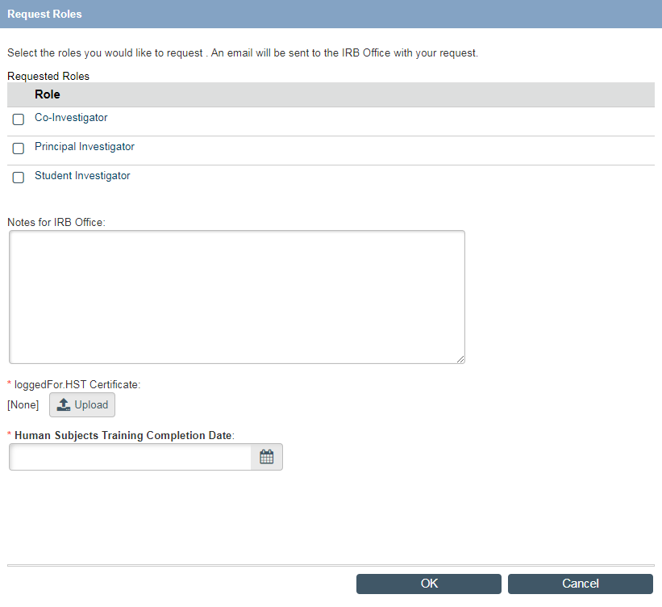
  - Click OK to submit your request to the IRB

Your request will be reviewed and user roles granted as appropriate. You will receive an email from PHIRST when your user roles have been assigned.

Once your account is complete with assigned user roles, you may begin creating an application.

Your PHIRST Homepage – My Inbox
Once you have your user roles, log back in to PHIRST; you will arrive at your PHIRST Homepage called

My Inbox.
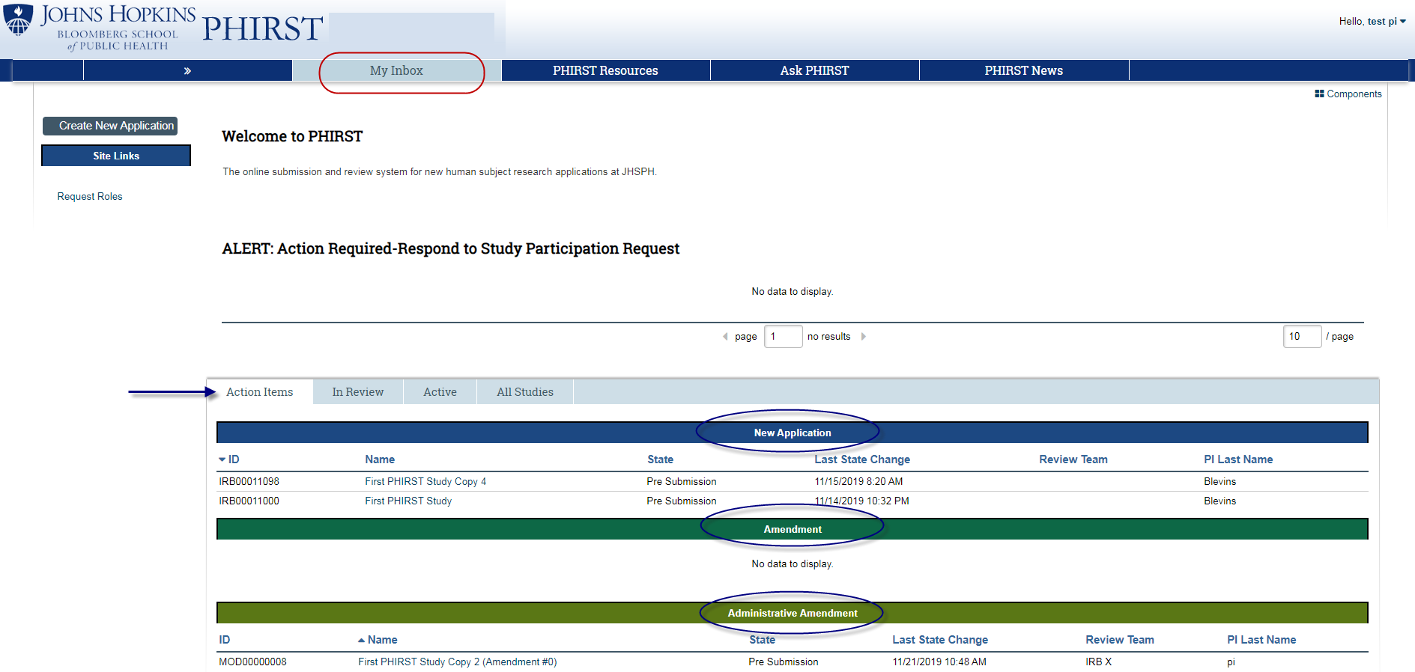
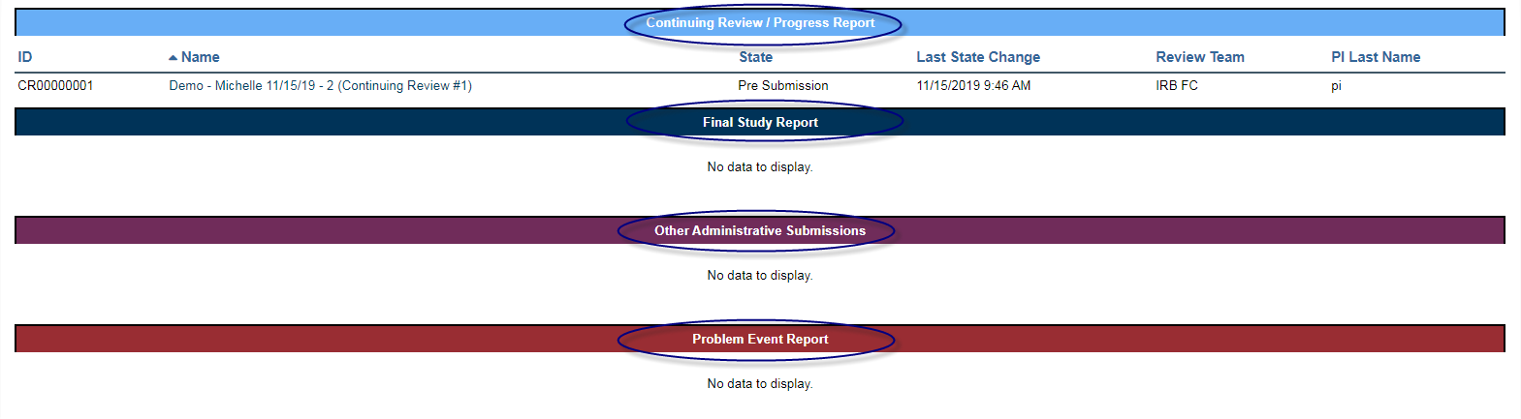

This page gives you access to all studies on which you participate as a PI or study team member in their various stages of a study lifecycle, including new applications and studies undergoing amendment or ongoing review.

Your studies are organized in tabs across the top half of the screen as follows:
- Action Items – study submissions that require your action. These could include pre-submission studies that require completion and submission, or other submissions (new applications, amendments, continuing review/progress reports, etc.) which have pending questions from the IRB.
- In Review – submitted studies that are under review by IRB staff or IRB reviewers.
- Active – approved studies that are still under active IRB oversight.
- All studies – all of YOUR studies, i.e., where you are listed with any role (PI, Co-investigator, etc.), and studies that may be archived or withdrawn.

Creating a New Application
The PHIRST system includes several pages of questions for you to complete that describe your study, and which provide places for you to upload your study documents (Research Plan, Consent Forms, HIPAA Application, Recruitment Materials, Instruments, etc.). Your responses to these questions must be consistent with the study information provided in your study documents. The IRB review will include both the responses to the PHIRST questions and the study documents.

Click on Create New Application in the upper left corner of your My Inbox homepage:

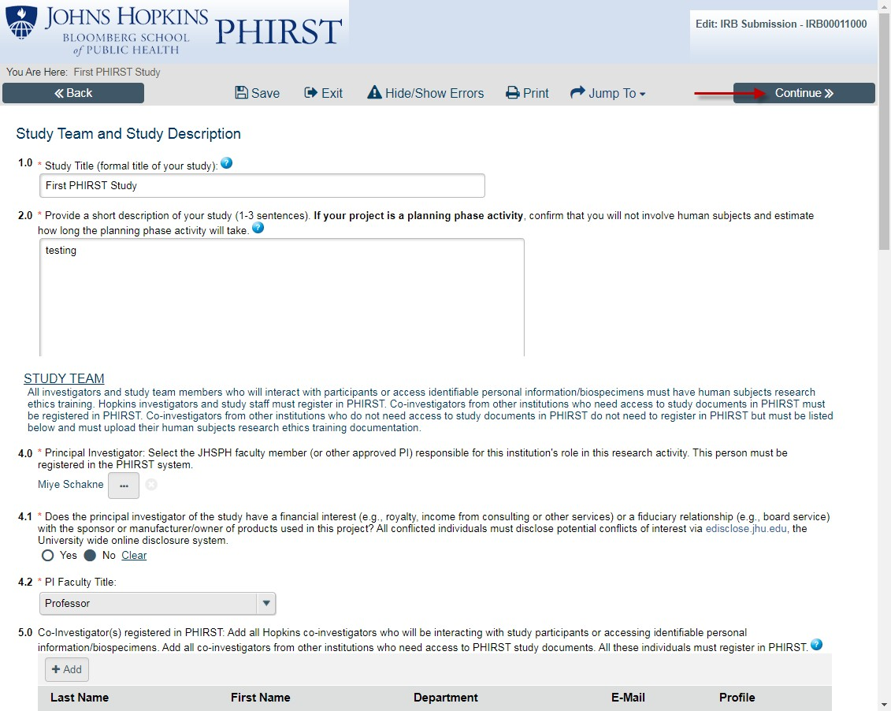
This opens up the first page of the questions in the PHIRST application, Study Team and Study Description. Required questions on this and all other application pages are marked with a red asterisk*. You must provide an answer to all required questions in order to successfully complete each page to “continue” to the next page, and to submit your application to the IRB. The application has a “smart form” structure, so your answers to questions on this first page determine by logic the questions you must answer on subsequent pages. Complete the first page and click Continue to save your answers; an IRB number will be assigned to your application at this point. Proceed to the next page. If you need to change an answer, you can go back and revise. The system has a “hide/show” feature; your answer may trigger additional questions to appear.

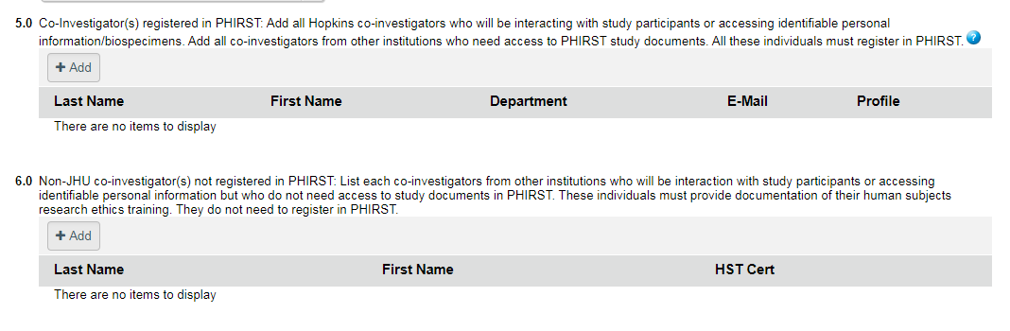
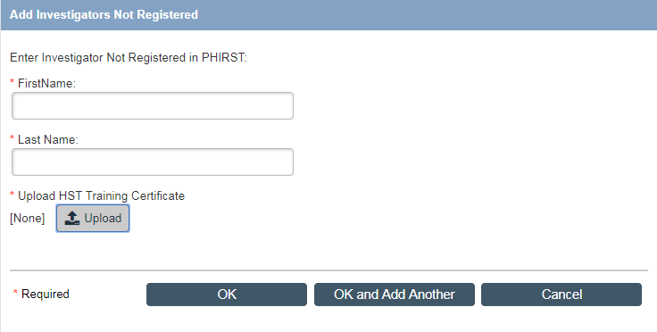
Adding Study Team members

As we mentioned earlier, there are two ways to add co-investigators and essential study team members to your application:
- Adding someone who has registered in PHIRST – In question 5.0, click “Add” to open a window where you can type in the individual’s name. The name of that registered user will display so that you can select that person. Click OK in the lower right side of the window and you will see the individual’s name listed in your application.

- New Feature: Adding a non-JHU co-investigator or essential study team member does not need access to PHIRST and study documents (and thus, doesn’t need to register in PHIRST) – The IRB does not need all non-JHU people to register in PHIRST, but does need to verify their agreement to participate in the study and their training certifications. For people who don’t need access to the study documents, use this method. In question 6.0, click Add to open a window where you can type in the individual’s name and upload that person’s human subjects research ethics training certificate and the completed “Investigator’s Agreement” available on the IRB website on the Amendments page. Click OK in the lower right side of the window to display the individual’s name.

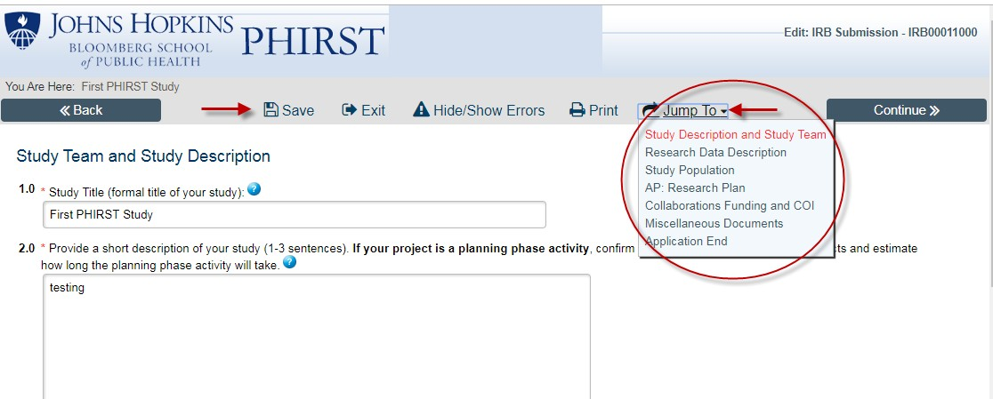
Navigation

PHIRST provides several tools in the Navigation bar across the top of the application: Save, Exit, Hide/Show Errors, Print, and Jump To. Please note – in order to save your answers, you must either click Save or Continue. The Back button will take you to the previous page but it will NOT save your answers.

The Jump To feature displays all the pages of your application and allows you to go directly to a later page in the application without having to click through each application page to get there. Do not use this feature when you are completing your new application because you don’t want to skip any important pages. It is a help when you are correcting or completing different pages or creating an amendment application once your study is active.

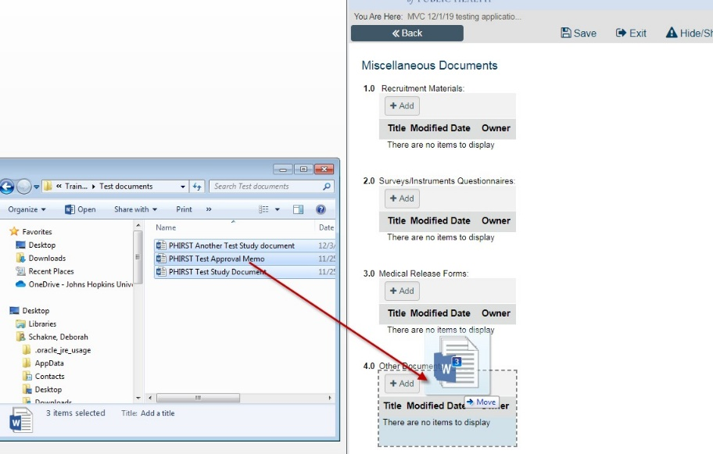
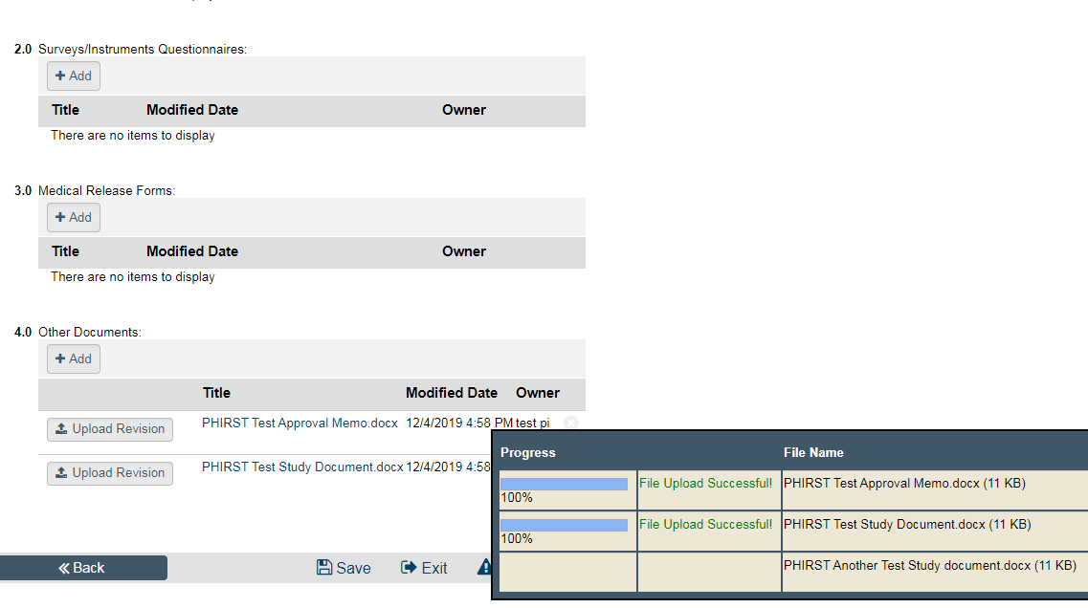
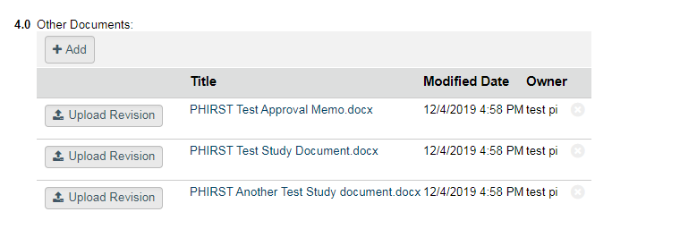
Uploading Documents

You are able to upload all study related documents in your PHIRST application. Specific sections and pages will have questions with upload areas for your Research Plan, Consent/Assent/Parental Permission forms, Surveys/Instruments, etc. ALL study related documents must be uploaded on the appropriate pages in the PHIRST application to provide a complete record of the study. Use the Miscellaneous Documents page to upload any documents specific to your study that fall outside the stated categories.

There are two types of upload fields throughout the application (the variability is beyond our control at the present time):
- “Drag and drop” – Hover over the upload area. If you see a message in orange, Drag and drop files to upload, you will be able to upload multiple documents at the same time. If this option is available, open up the folder where your documents reside, click on one or more documents you wish to upload (using the “Shift” key for a continuous group or the “Ctrl” key for specific documents), and drag them over to the upload area. The selected documents will automatically copy into the upload area field.

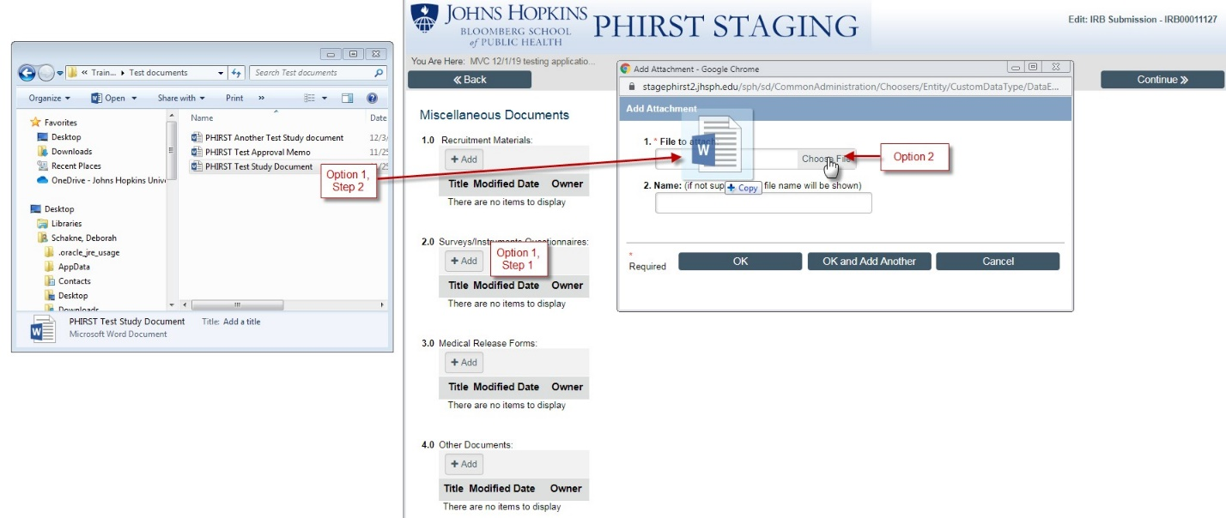
- If a true “drag and drop” option is not available (no orange message), click on “Add” to open the “Add Attachment” window. Option 1 – drag individual documents from your folder into this window, but only one document at a time. Option 2 – click “Choose File”, select your document from your folder and click “Open” to upload the document.

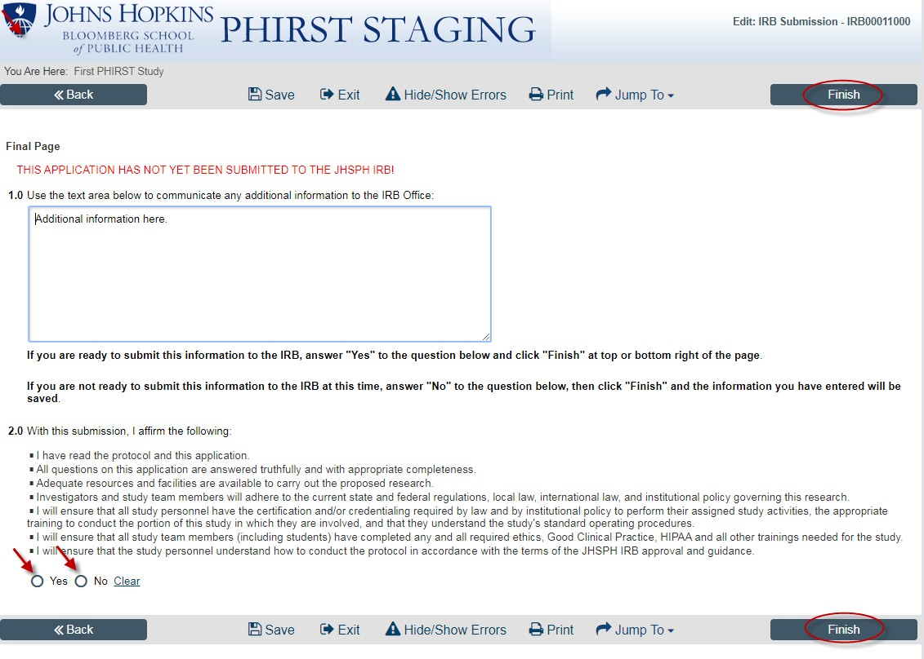
Submitting your application

When you arrive at the last page of the application, you have two choices:
  - If you are finished with the application and are ready to submit it to the IRB, check YES on question 2.0, and click FINISH at the top or bottom right of the screen to automatically submit the application to the IRB Office.
  - If you are not ready to submit the application, check NO on question 2.0 and then click FINISH. This will save the information you have entered and allow you to return to the application at a later time to continue work on it. The application will appear in the “Action Items” tab of your Homepage. The registered users that you have added to the application will see the application in their “Action Item” tab on their PHIRST Homepage.

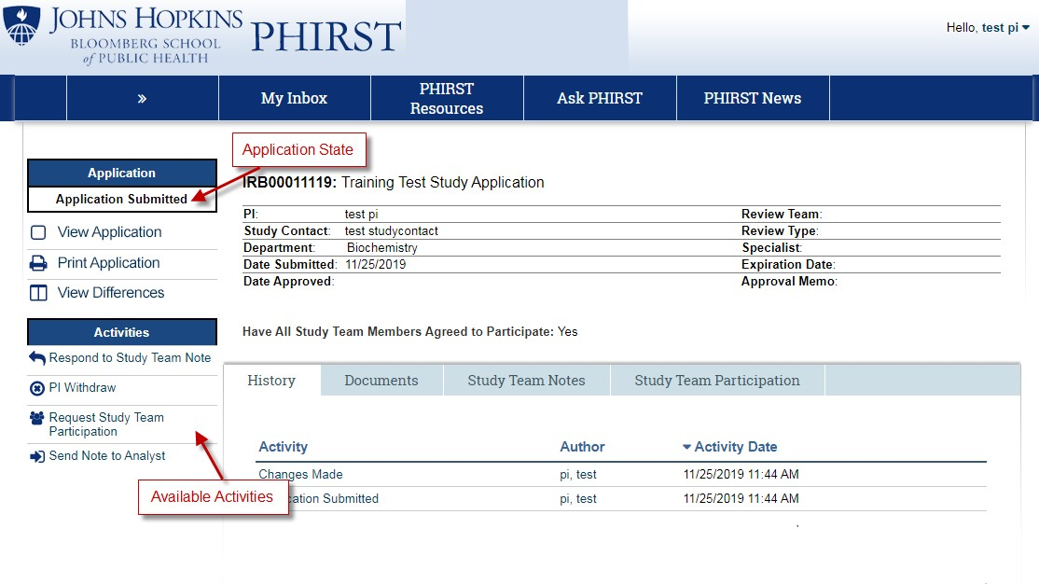
The Application Workspace
Every study in PHIRST, from pre-submission through approval, has its own Application Workspace. Think of it like a file folder identifying the study and key information related to the study, including the Study ID Number, Study Title, PI, and the status of the application.

- Application State – On the upper left side of the screen is the application state. This will tell you at a glance the current state or status of you application at any point in the IRB review process. Studies that have yet to be submitted are in “Pre-Submission”; studies that have been submitted and assigned to an IRB review team are “In Review”; approved studies are “Active”. There are other
sub-categories under the “In Review” state as the submission communications go back and forth between the IRB and the PI. Studies determined to be “Not Engaged in Human Subjects Research” or “Not Human Subjects Research” go straight to “Archives”; completed and closed studies will also be moved to “Archives”.

Under the “Application State” header are different ways you can access your application information. “Edit Application” allows you to make changes to the application. “View Application” gives you access to each page of the PHIRST application, page by page, without editing capacity. “Print Application” is a view that gives you a one, long page that includes all of the PHIRST application pages. “View Differences” is a tool used with Amendment Applications; it will show the changes in the revised application.

- Activities – On the left side of the screen, under the study state are a list of Activities. You will see only those activity options available to you in any given state. For example, when you submit an application, the activities differ from the activities that appear in “Concerns Pending”, when the IRB has sent you concerns or questions to respond to. The list of activities changes as the study progresses through the review process to allow you to communicate with the IRB.

- Tabs – The tabs organize application information in a logical and accessible format. For example, instead of paging through the application to find a document, you can just click on the Documents tab, where all documents uploaded in the application are available in a list.

- Study Information – The area at the top of the screen, under the Study Title, will populate with information from submission of the application through completion of the IRB review and eventual approval. When a study is approved, the relevant dates (approval/expiration) will display, along with a link to your Approval Memo.

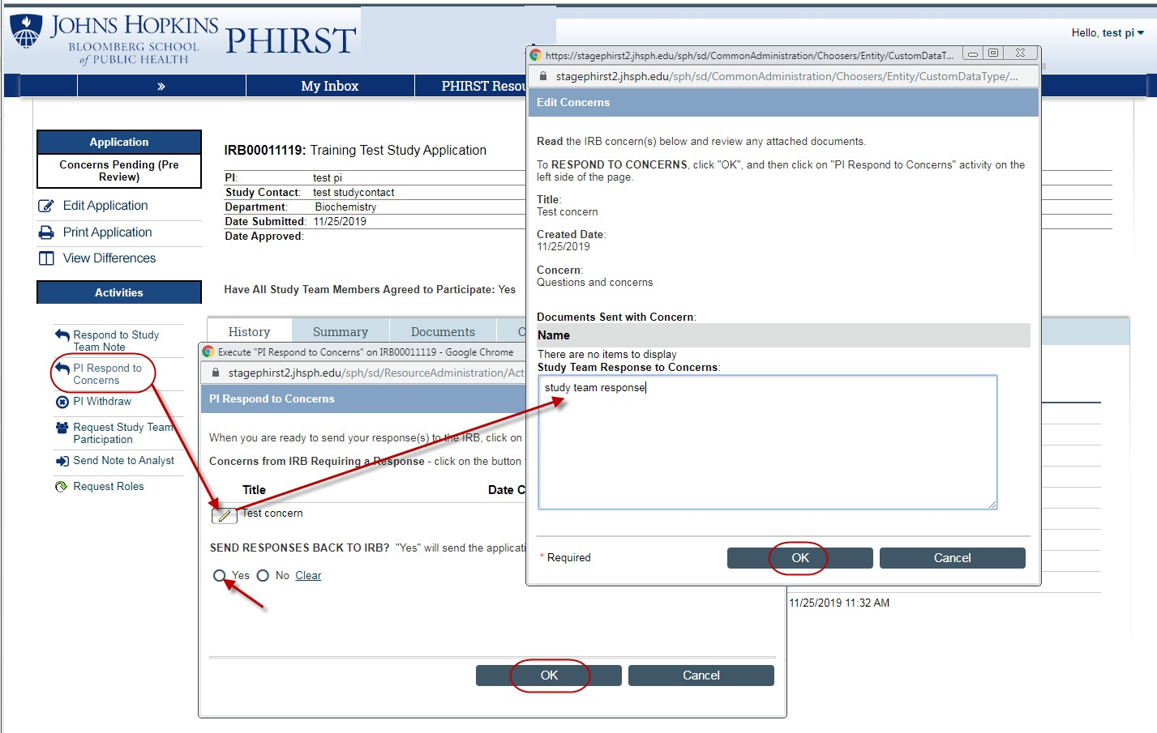
Application Review Process
When the IRB receives your submitted application, it is assigned to one of the IRB staff review teams: Exempt, IRB X, or IRB FC. An IRB Analyst will perform an initial review of the submission and will assign it to IRB committee members for review, if appropriate. The Analyst will communicate with the PI through PHIRST by sending “Concerns” which require a timely response to keep the review moving forward.

Responding to Concerns:

When the IRB has questions about your study while it is under review, the IRB Analyst and/or IRB member/reviewer will enter those questions as “Concerns” in your PHIRST application. The Analyst will then send the study back to you to address/answer those questions. You will receive a PHIRST email, “ACTION REQUIRED: Respond to Concerns”, with a link to the study. When you log in, you will be able to view and respond to the concern(s). Click on the “Respond to Concerns” activity. Then click on the pencil icon next to the concern. This opens up a window where you can type in your response to the concern in a text box. Click OK in the window to save your response. When you are ready to send your response(s) back to the IRB, check YES under “SEND RESPONSES BACK TO IRB” and click OK. Please note
- If you fail to click “OK,” your response will not return to the IRB.

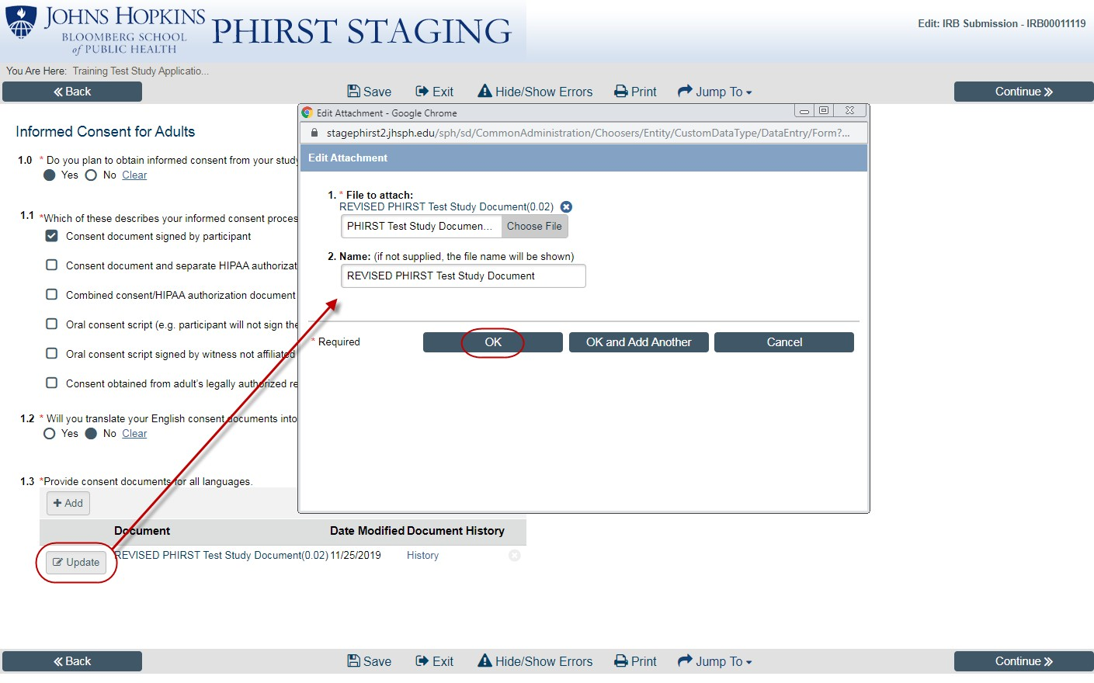
Revising documents in response to IRB concerns:

When you are asked to revise submitted documents, make sure to turn on “Track Changes” in your Word document so the IRB can easily see the revisions you have made. Make sure to return to the application page where the original document was uploaded and upload your revision there.

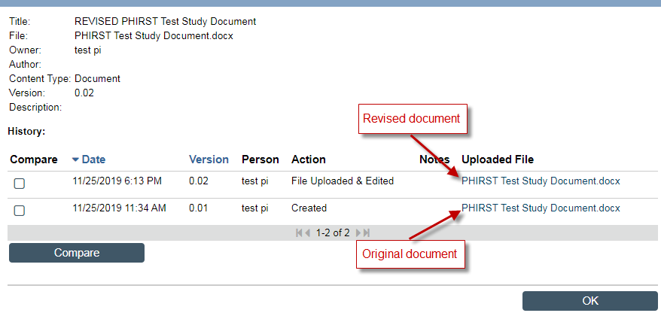
Both your original document and your revised document will be available to the IRB to review.

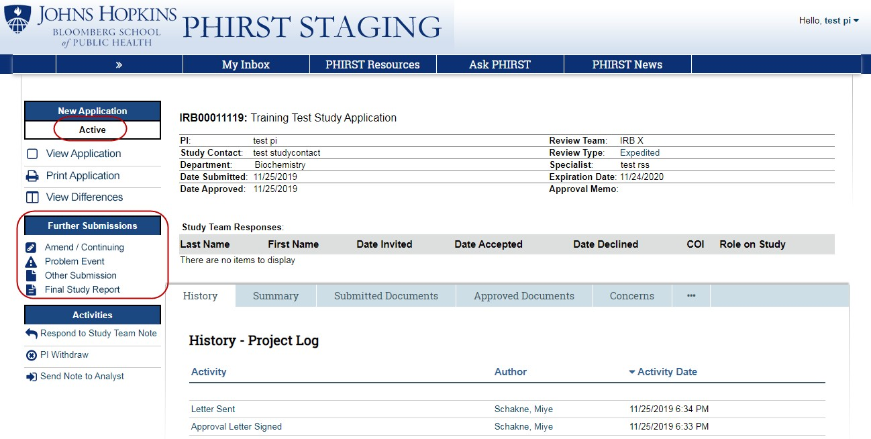
Your Approved Application!
When the IRB determines that your application is complete and that all concerns have been addressed, the IRB will make a final determination about your application. If approved, you will receive an email from PHIRST, “FYI: Application Approved”, and when you log in, you will see that the application state is now “Active”.

After Initial Approval

Once your study is Active, you may submit future IRB reports (“Further Submissions”) through the PHIRST system.

On the left side of the screen, you will see “Further Submissions”. Click on the appropriate link:
- When there are changes to your study requiring an Amendment or Administrative Amendment
- When your study is due for Continuing Review
- To report problem events
- To submit administrative study documents
- To close your study with a Final Study Report

Further Submissions

Amendments

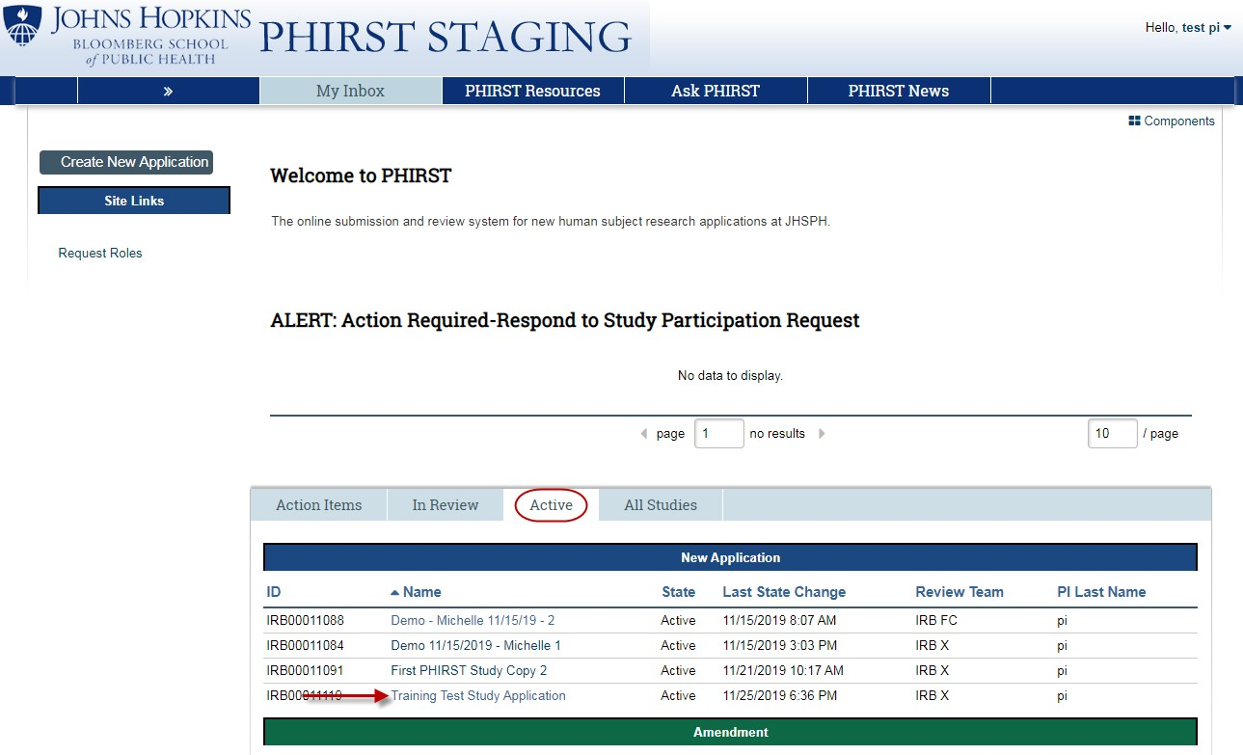
To start an amendment, log in to PHIRST and click on the Active tab to view your approved studies. Find the study you wish to change and click on study title link to go to the study workspace.

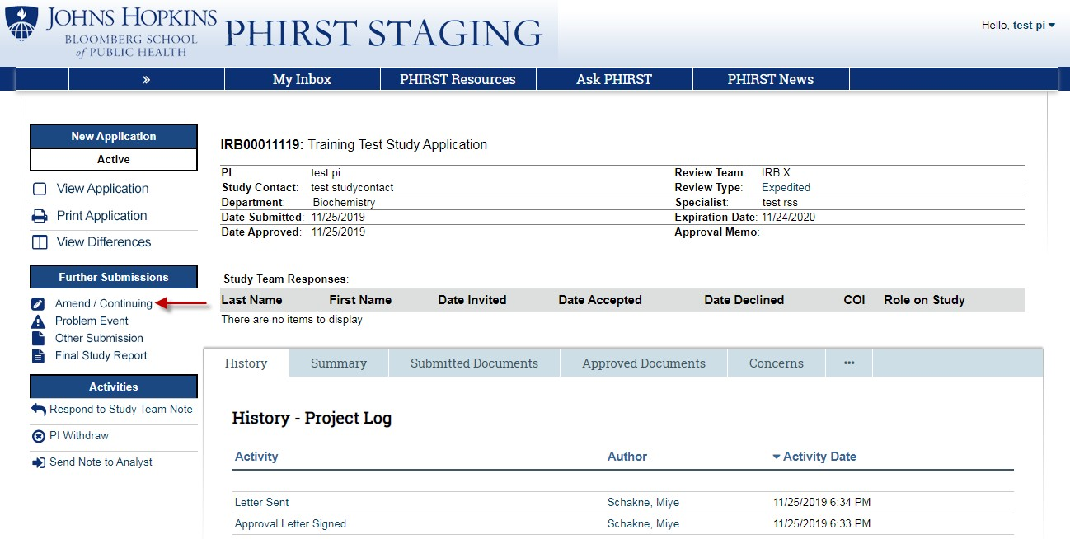
On the left side of the study workspace, click on the “Amend/Continuing” link.

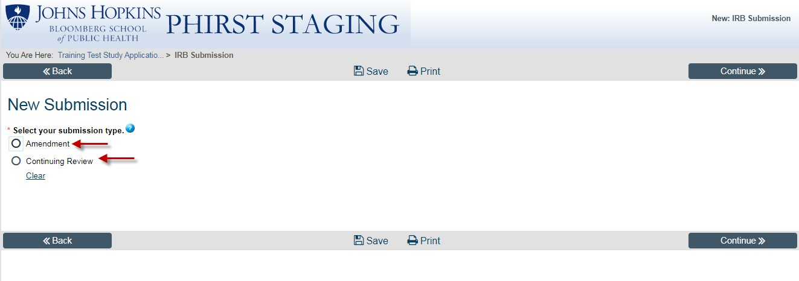
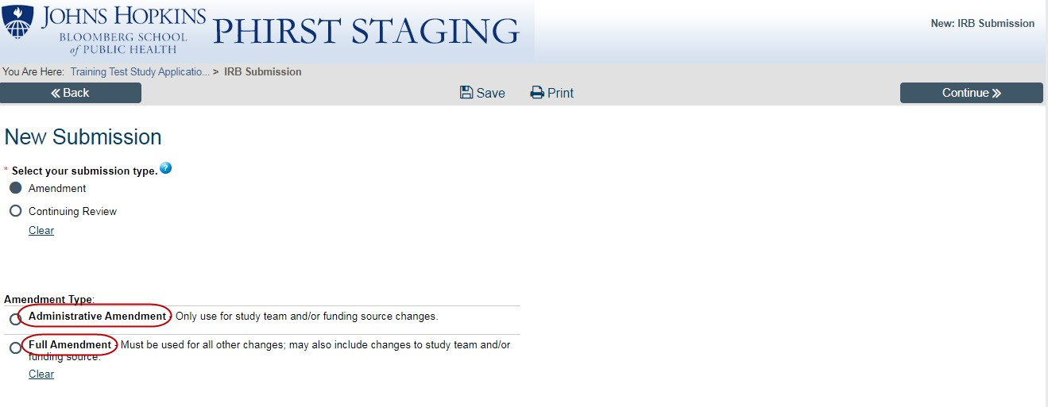
This will open a new page where you will see “Amendment” and “Continuing Review”. This is how you open new submissions to work on; select “Amendment”.

When you click on Amendment, you can choose either an Administrative Amendment to change study team or funding, or a Full Amendment. (Note: you may also make study team and funding changes in a full amendment along with your other changes). You may only submit one of each type of Amendment at a time; the earlier amendment must be completed before submitting another one. If an Administrative Amendment overlaps with a Full Amendment, the last one approved will overwrite the other one.

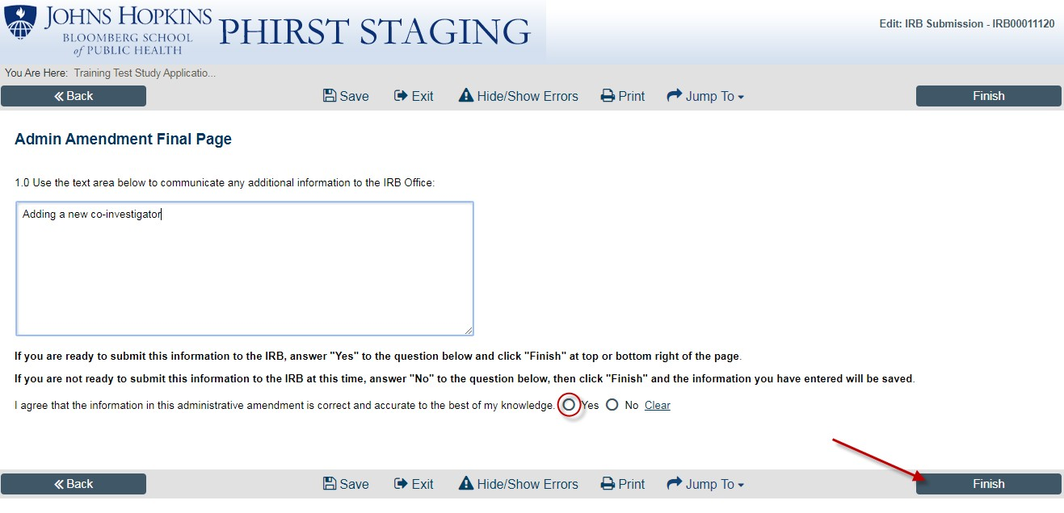
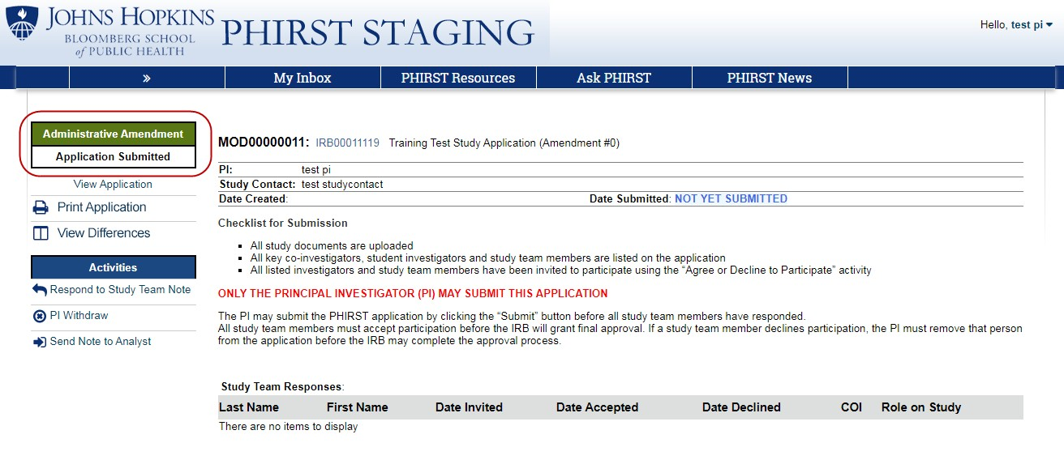
The administrative amendment is a two page application where you can make changes to your list of co- investigators, student investigators, or study contact, and to your funding information. As with the new application, you can submit the administrative amendment from the second (Final) Page, by answering YES to the statement, “I agree that the information in this administrative amendment is correct and accurate to the best of my knowledge” and clicking FINISH.

Your administrative amendment is now submitted to the IRB.

The first page of a Full Amendment asks you to provide information on the changes you are making to your study. There are two kinds of changes: changes to the PHIRST application, which will appear in “View Differences”, or changes to study documents. You must describe each change individually and provide your reason for making that change. If you are submitting new documents, you must clarify if you are submitting revisions to currently approved documents (will need track/changes) or you are submitting new, previously not reviewed documents.
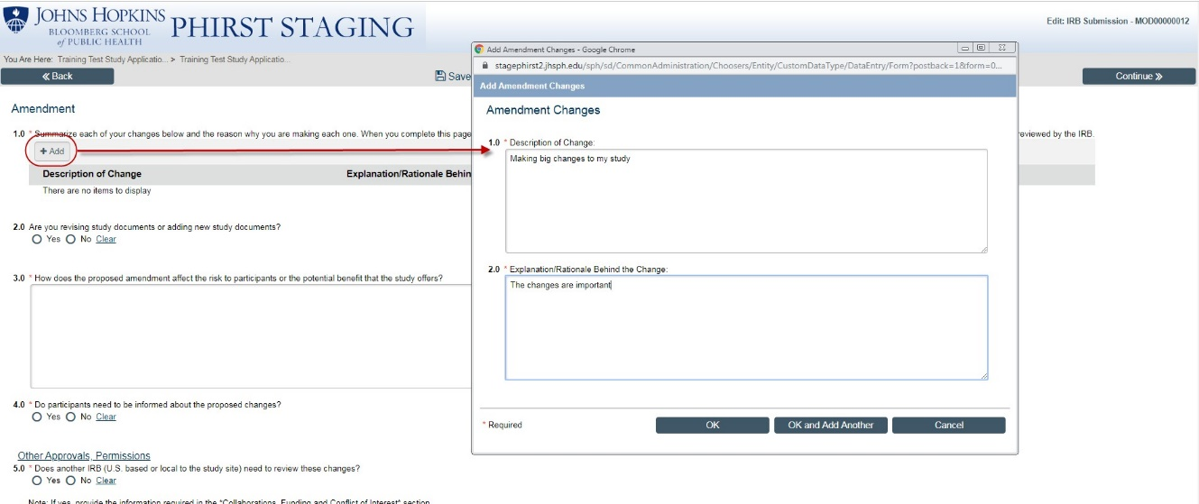

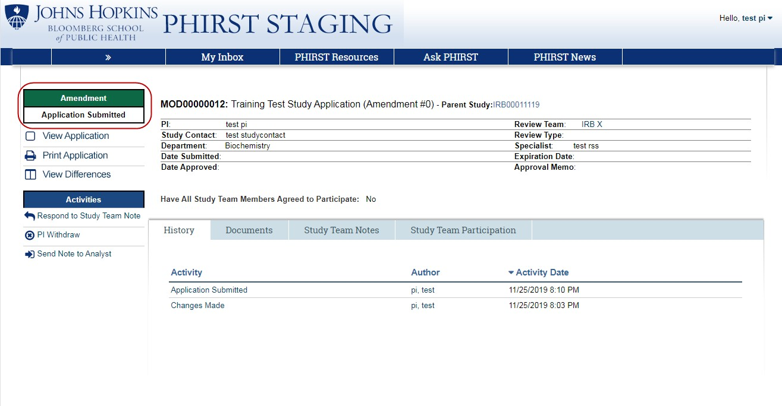
After you complete the questions on this page and click Continue, you will arrive at a copy of your original approved study application. If you are making changes to the PHIRST application, make the needed changes on the relevant pages of the application and when you are ready, submit the full amendment from the final page.

Further Study Submissions: Continuing Reviews, Other Administrative Submissions, Final Study Report

Review for all further submissions follows the same process as the review process for the New Application and Amendments. During the review, the IRB will send you “Concerns” and you will respond to those concerns using the same activities as you have in the new application. When all concerns have been addressed, the IRB will make a final determination about the submission.

A few things to keep in mind:
You can submit an administrative amendment and a full amendment at the same time, but no more than one of each at any given time. To avoid confusion, it is recommended that if you have both substantive study changes and study team or funding changes, combine them in one full amendment to ensure that all the requested changes are approved together. However, if you have study team members who must be added immediately, and before review of a full amendment is complete, the administrative amendment option is available to you.

You can submit a continuing review while an amendment is under review (and vice versa) but it is important to communicate with the IRB to ensure that all elements of both submissions are harmonized during the review process.

You can submit multiple problem event reports as needed.

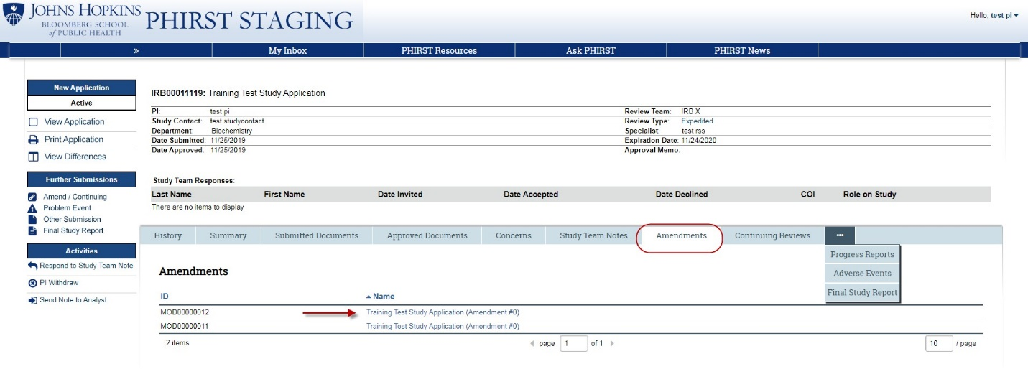
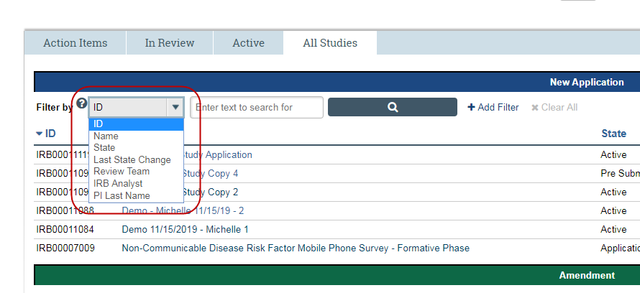
Finding your Further Study Submissions
Once your study is approved and active, you will see in the study file a series of tabs across the page, starting with “History” and moving from left to right, and including tabs for your Amendments, Continuing Reviews, etc.

You can also locate further submissions from your PHIRST My Inbox homepage. Look under each of your tabs, “Action Items”, “In Review”, “Active”, and “All Studies”. New applications and further submissions will be listed under their appropriate area. The “All Studies” tab has a search feature that allows you to search using several options including study title, PI last name, study state and so on.

Addendum A

Requesting an Ad-hoc JHED ID for PHIRST Registration:

Send an email to the PHIRST Help Desk, JHSPH.phirsthelp@jhu.edu with AD-HOC JHED ID Request in the subject line. Include the following information in the email:
- First and last name
- Birthdate
- Email address

Someone from the PHIRST Help Desk will email you to confirm your request and gather some additional information. When your ad-hoc JHED account has been created, you will receive a confirmation email from the PHIRST Help Desk with your ad-hoc JHED ID.

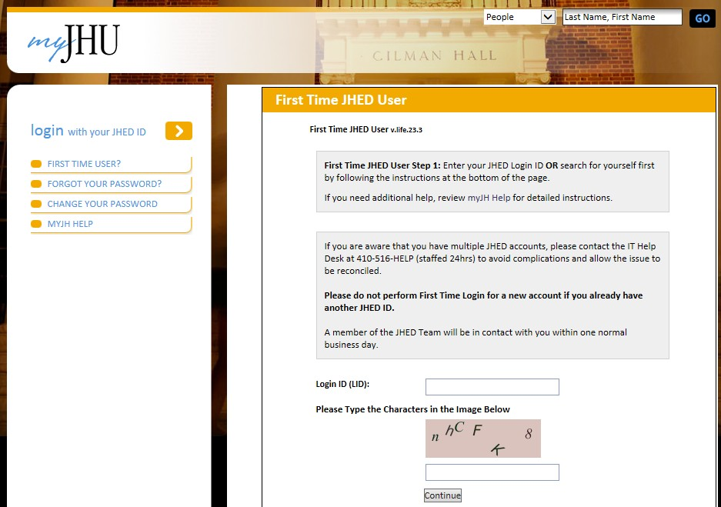
Before you can log into PHIRST, you must log in to the JHED system, https://my.jh.edu/portal/web/jhupub/login-firsttimejheduser, in order to create a password.

When you complete your JHED registration and have a confirmed JHED password, go to the PHIRST login page, https://phirst.jhsph.edu/. Log in using your JHED ID and JHED password. Follow the instructions in the PHIRST User Guide to request user roles.

